# Create an app that takes two config userObject and OrderObject

**userObject** = {

address: string;

name: string;

phoneNumber: Number;

email:string;

};

**orderObject** = {

orderType: "cod" | "upi";

amount: Number;  
};

PS. Mentioned values/ accepted data types next to fields

# Functionality required-

* POST call to dummy url on send click - URL (localhost:8080/send) Body -{amount and phone number}
* Show only PhonePe and Google Pay buttons for iOS Devices. All 4 buttons for Android. Show text “No payment options available” for desktop.
* Desktop view will be the same as the design as mobile, in the center of the screen with maximum height around 80%.
* Phone number should be editable, and new phone number should go in the post call.
* The order amount should come from the order object.
* COD/ UPI order page should open dependent on the value passed in order object.
* UPI button function.
  + If a non empty user object exists, the click should trigger GET call - URL (localhost:8080/{UpiName})
  + If the user object is empty, it should open a form where the required details can be filled, and on clicking on submit, should trigger GET call - URL (localhost:8080/

{UpiName})

* The phone number field should be filled when the phone number is available in the user object.

Design can be found at the bottom.

PS.

* Show proficiency in React, Svelte, Angular, or Vue through clean code standards, formatting, and modularized code for UI components and services.
* Make the UI responsive and clean. The screen caps are for reference.
* The API calls will fail, but that’s not an issue.
* Use the radio button instead of the toggle switch if required.

# Preliminary CSS

.pay-btn {

width: 100%; background: #004b8d; border: none;

border-radius: 10px; margin: 0.3rem 0;

padding: 0 1rem; height: 52px; display: flex;

justify-content: space-between; align-items: center;

cursor: pointer;

}

UI screencaps

Input form ->

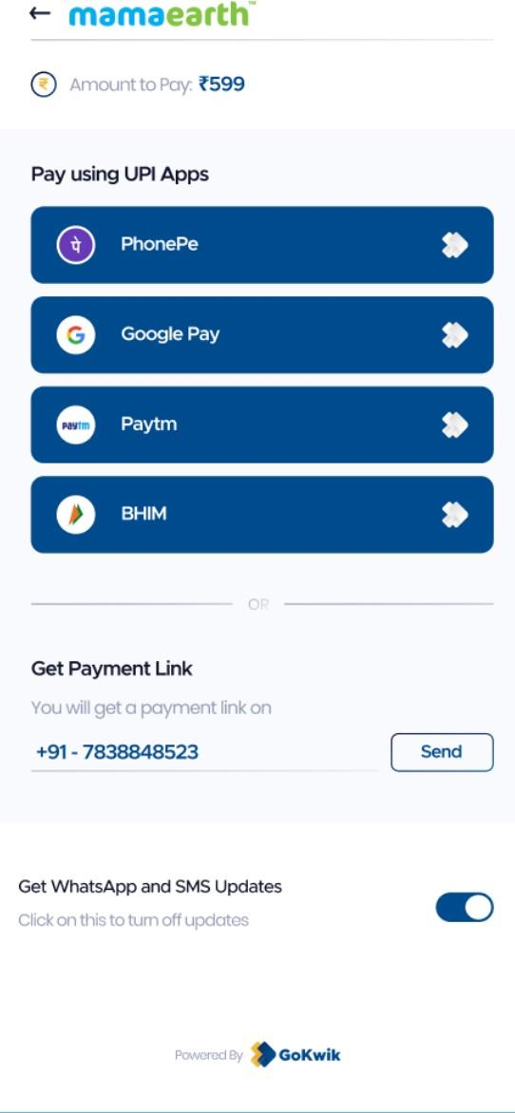

UPI page COD page